**Module 1 – Overview of IT Industry**

**What is a Program?**

* **LAB EXERCISE**: Write a simple "Hello World" program in two different programming languages of your choice. Compare the structure and syntax.

**Example 1:** Java:

public class HelloWorld {

    public static void main(String[] *args*) {

        System.out.println("Hello, Welcome to Tops Technology");

    }

}

**Example 2:** Python**:**

print("Hello, Welcome to Tops Technology ")

**Comparison:**

* **Structure:** Java demands a class definition and main method to run, while Python runs immediately with a one-line statement without definition.
* **Syntax:** Java uses semicolons, which enclose the statements by using curly braces, whereas Python uses indentation and simplicity with no semicolon.
* **THEORY EXERCISE: Explain in your own words what a program is and how it functions.**

A program is a set of instructions written in a programming language to perform a particular task. It works by translating a compiler or an interpreter into machine code that a computer will use to accomplish the outcome.

**What is Programming?**

* **THEORY EXERCISE: What are the key steps involved in the programming process?**
* **Problem Analysis**: Understand the problem, define objectives
* **Algorithm Design**: Develop a step-by-step plan or algorithm.
* **Coding**: Translate the program into a programming language.
* **Testing and Debugging**: Find and remove errors from code.
* **Implementation**: Deploy the program to be used by others.
* **Maintenance**: Update and improve the program over time.

**Types of Programming Languages**

* **THEORY EXERCISE: What are the main differences between high-level and low-level programming languages?**

|  |  |  |
| --- | --- | --- |
| **Feature** | **High-Level Languages** | **Low-Level Languages** |
| **Abstraction** | Easier to understand, closer to everyday language | Closer to how computer works, more difficult to understand |
| **Ease of Use** | Easier to write and read | More difficult to write and understand |
| **Portability** | Can easily run on many different computers | Usually only run on specific kinds of computers |
| **Speed** | Runs slower because there are extra layers of processing | Runs faster, is executed directly on the hardware |
| **Memory Management** | The computer manages the memory for you | You need to manage memory yourself |
| **Examples** | Python, Java, C++, JavaScript | Assembly, Machine Code |
| **Error Handling** | Built-in tools to catch errors | You have to handle errors manually |
| **Development Time** | Takes less time to write code | Takes more time because of the detailed control needed |

**World Wide Web & How Internet Works**

* **LAB EXERCISE: Research and create a diagram of how data is transmitted from a client to a server over the internet.**

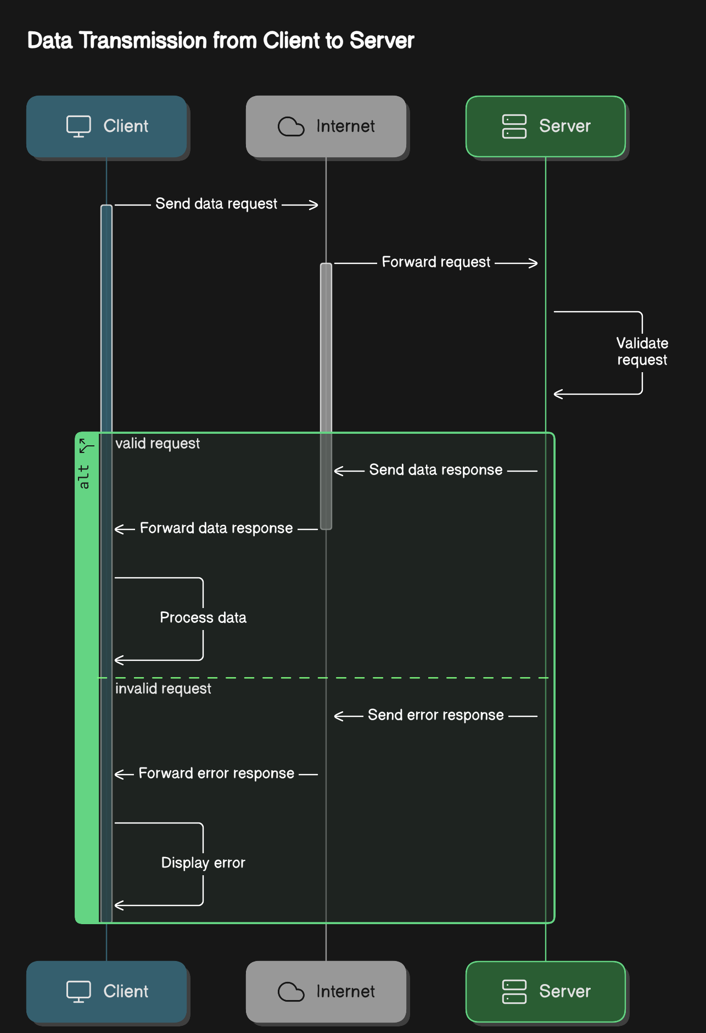

* **THEORY EXERCISE: Describe the roles of the client and server in web**
* **Client:** Requests resources or services, such as a web browser requesting a website.
* **Server:** Receives and processes client requests and sends appropriate responses or resources.

**Network Layers on Client and Server**

* **LAB EXERCISE: Design a simple HTTP client-server communication in any language.**

**Server (Node.js)**

const http = require('http');

// Create the server

const server = http.createServer((req, res) => {

    // Set the response header

    res.setHeader('Content-Type', 'application/json');

    // Check the request method and URL

*if* (req.method === 'GET' && req.url === '/message') {

        // Respond *with* a JSON message

        res.statusCode = 200;

        res.end(JSON.stringify({ message: 'Hello from the server!' }));

    } *else* {

        res.statusCode = 404;

        res.end(JSON.stringify({ error: 'Not Found' }));

    }

});

// Define the port and start the server

const port = 3000;

server.listen(port, () => {

    console.log(`Server running at http://localhost:${port}`);

});

**Client (Node.js)**

const http = require('http');

// Make a GET request to the server

http.get('http://localhost:3000/message', (res) => {

    let data = '';

    // Collect data chunks

    res.on('data', *chunk* => {

        data += chunk;

    });

    // When the response ends, print the result

    res.on('end', () => {

        console.log('Response from server:', JSON.parse(data));

    });

}).on('error', (err) => {

    console.log('Error:', err.message);

});

* **THEORY EXERCISE: Explain the function of the TCP/IP model and its layers.**

**Function of the TCP/IP Model**

The TCP/IP model is a set of rules that allow different computers and devices to speak to each other over a network, like the Internet. It organizes how data is sent, received, and understood in four layers.

**Layers of the TCP/IP Model**

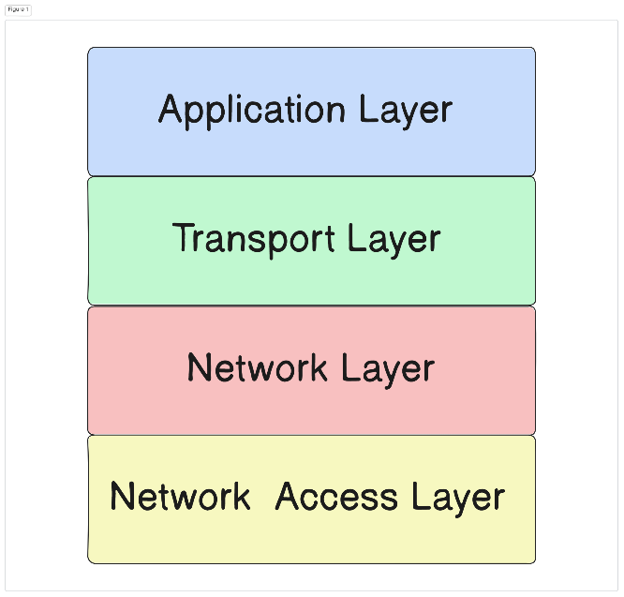

1. **Application Layer**

* This is the layer we are familiar with, such as accessing websites, emails, and apps.
* It makes sure your app (like a browser) can send or receive data correctly.
* Examples: Browsing a website (HTTP), sending emails (SMTP), File transfer (FTP).

1. **Transport Layer**

* Acts as the "delivery guy" for data. It breaks the data into smaller pieces (packets) and ensures they arrive correctly and in order.
* Types of delivery:
  + TCP: Reliable delivery, used for things like web pages and emails.
  + UDP: Faster but less reliable, used for live streaming or online games

1. **Internet Layer**

* Imagine this layer as a GPS. It finds the best route for your data to travel across networks.
* Assigns IP addresses to devices so data knows where to go.

1. **Network Access Layer**

* Handles physical data transmission, such as a wire , Wi-Fi, and other hardware.
* Converts data into signals like electrical pulses or radio waves so that it flows from one device to another
* **Example in Simple Terms**
* Imagine you order a pizza online:
  1. You (the client) ask for a pizza through an app (Application Layer).
  2. The app prepares your order and sends it for delivery (Transport Layer).
  3. The delivery service plans the best route to your house (Internet Layer).
  4. The pizza is delivered using roads and vehicles (Network Access Layer).

**Client and Servers**

* **THEORY EXERCISE: Explain Client Server Communication**

Client-server communication is a basic model in computer networking where a client device or application requests services or resources from a server, which processes the request and provides a response.

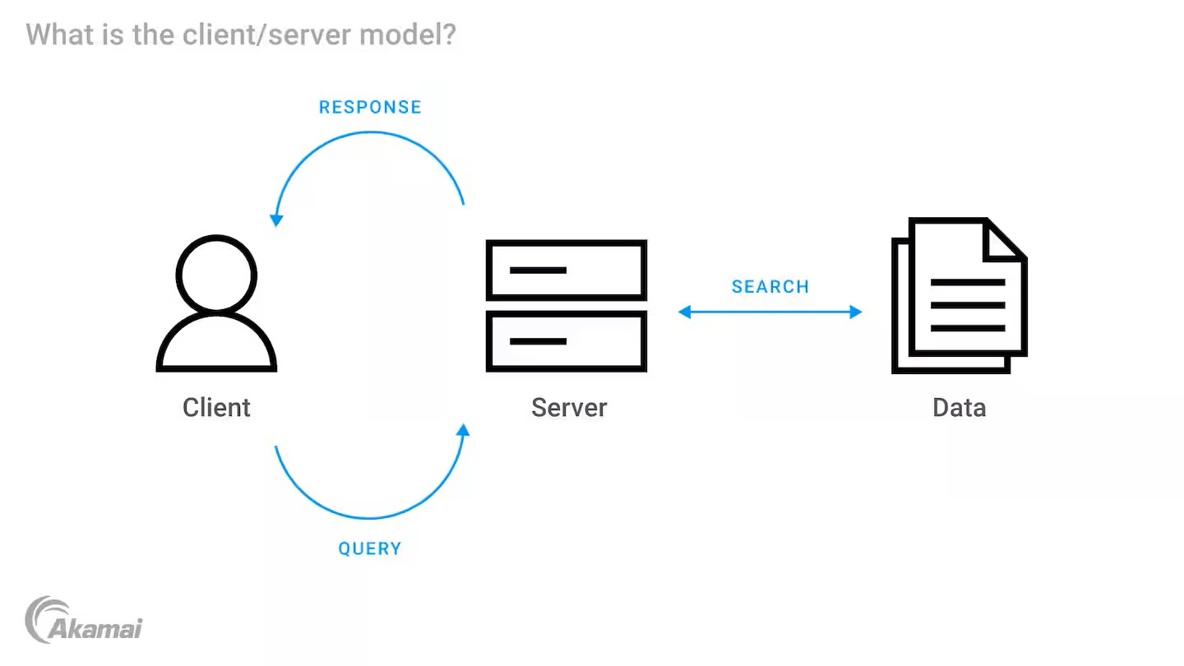

**Key Elements**

* **Client:**
* The client is the device or the application requesting a service or data.
* Examples: Web browsers, mobile apps, and IoT devices
* **Server:**
* The server is a central system or an application which provides the requested services or data.
* Examples: Web servers, database servers, and application servers.

**How Communication Works**

The communication between the client and server generally follows these steps:

1. **Request Initiation:**
   * The client sends a request to the server over a network (e.g., HTTP request in a web application).
2. **Request Processing:**
   * The server receives and processes the client's request.
   * It may involve querying a database, running an algorithm, or fetching a file.
3. **Response Delivery:**
   * The server sends the processed data or results back to the client.
4. **Rendering or Execution:**
   * The client processes the server's response to display the information or perform an action.

**Communication Protocols**

The client-server model uses various protocols to facilitate communication:

* **HTTP/HTTPS:** For web communication**.**
* **FTP:** For file transfers.
* **SMTP/IMAP:** For email services.
* **Web Sockets:** For real-time communication.

**Example of Client-Server Communication**

**Web Browsing:**

1. **Client:** A user enters a URL in a browser (e.g., www.example.com).
2. **Request:** The browser sends an HTTP request to the web server.
3. **Server:** The web server processes the request, retrieves the requested webpage, and sends it back as an HTTP response.
4. **Response:** The browser renders the webpage for the user.

**Challenges**

1. **Single Point of Failure:** If the server fails, clients lose access to resources.
2. **Latency:** Communication over a network can introduce delays.
3. **Scalability Issues:** High traffic can overload a server.

**Types of Internet Connections**

* **LAB EXERCISE: Research different types of internet connections (e.g., broadband, fiber, satellite) and list their pros and cons.**

**1.Broadband (DSL, Cable, Fiber)**

* **Pros**: High-speed, reliable, widely available.
* **Cons**: Can be expensive, speeds may slow during peak hours, distance impacts DSL speeds.

**2. Fiber Optic Internet**

* **Pros**: Fastest speeds, reliable, future-proof.
* **Cons**: Limited availability, expensive installation.

**3. Satellite Internet**

* **Pros**: Available in remote areas, no cables required.
* **Cons**: Slow speeds, high latency, weather-sensitive, data caps.

**4. Mobile Hotspot (4G/5G)**

* **Pros**: Portable, fast with 5G.
* **Cons**: Coverage limitations, data limits, battery drain.

**5. Fixed Wireless Internet**

* **Pros**: Good for rural areas, moderate speeds.
* **Cons**: Requires line of sight, weather sensitivity.
* **THEORY EXERCISE: How does broadband differ from fiber-optic internet?**

**1. Technology**

* + - **Broadband:** A data signal delivered over copper or coaxial cables.
    - **Fiber-Optical:** Thin glass or plastic fibers that carry information in the form of light signals.

**2. Speed**

* + - **Broadband:** Slower; runs between 10 mbps and 1 gbps.
    - **Fiber-Optical:** Much faster; speeds sometimes exceed 10 gbps and beyond.

**3. Reliability**

* + - **Broadband:** Slows down in peak hours and remains susceptible to distance and to weather.
    - **Fiber-Optical:** Much more stable, unaffected by weather and interference.

**4. Price**

* + - **Broadband:** More affordable; wider availability.
    - **Fiber-Optical:** Quite expensive but costs are declining.

**5. Availability**

* + - **Broadband:** Usually anywhere; even in rural areas.
    - **Fiber-Optical:** Mainly urban and suburban; now entering the rural areas.

**6. Use Cases**

* + - **Broadband:** Good for general internet use; including browsing and streaming.
    - **Fiber-Optical:** Most suitable for gaming and quite good for 4K and 8K streaming with multiple users and devices.

This means that fiber-optic is faster and more reliable while broadband is cheap and has many availability sites.

**Protocols**

* **LAB EXERCISE: Simulate HTTP and FTP requests using command line tools (e.g., curl).**

**HTTP Requests**

1. **GET Request**:

curl <http://example.com>

1. **POST Request:**

curl -X POST -d "username=test&password=12345"

<http://example.com/login>

1. **Download a File:**

curl -O <http://example.com/file.zip>

**FTP Requests**

* 1. **List Files:**

curl ftp://ftp.example.com --user username:password

* 1. **Upload a File:**

curl -T myfile.txt ftp://ftp.example.com/ --user username:password

* 1. **Download a File:**

curl -O ftp://ftp.example.com/myfile.txt --user username:password

* **THEORY EXERCISE: What are the differences between HTTP and HTTPS protocols?**

|  |  |  |
| --- | --- | --- |
| **Aspect** | **HTTP** | **HTTPS** |
| **Definition** | Hyper Text Transfer Protocol for plain text data transfer. | Hyper Text Transfer Protocol Secure with encryption for secure communication. |
| **Security** | No encryption; vulnerable to attacks. | Encrypts data using SSL/TLS, ensuring secure transfer. |
| **Data Protection** | Data can be intercepted or altered. | Ensures confidentiality, integrity, and authenticity of data. |
| **Port Used** | Operates on **port 80**. | Operates on **port 443**. |
| **Website Indicators** | URL starts with http://. Modern browsers may flag as "Not Secure." | URL starts with https:// and shows a padlock icon for security. |
| **SEO and Trust** | Less trusted by users and search engines. | Preferred by search engines and builds user trust. |
| **Cost** | Free; no need for certificates. | Requires an SSL/TLS certificate; may involve costs, though free options are available. |

**Application Security**

* **LAB EXERCISE: Identify and explain three common application security vulnerabilities. Suggest possible solutions.**

**1. SQL Injection**

* **Explanation**: Malicious SQL queries manipulate the database.
* **Solution**: Use **prepared statements** and **input validation**.

**2. Cross-Site Scripting (XSS)**

* **Explanation**: Malicious scripts steal data from users.
* **Solution**: Implement **output encoding** and use **Content Security Policy (CSP)**.

**3. Cross-Site Request Forgery (CSRF)**

* **Explanation**: Attacker tricks users into performing unwanted actions.
* **Solution**: Use **anti-CSRF tokens** and **SameSite cookies**.
* **THEORY EXERCISE: What is the role of encryption in securing applications?**

It can also be referred to as a lock to your data. It will only be opened by the person to who it is meant. Here are a few ways encryption enhances the security of your applications:

**1. Secured Data**

**What it does** : Encryption is basically taking the text of data and scrambling it against plain text. If a person gets hold of the encrypted data, they aren't going to understand it.

**Example**: Anytime you send a password through the internet, it is the last to be seen in transfer without encryption.

**2. Ensuring Untouched Data**

**What it does**: Encryption checks if data while transmission is modified by someone or not.

**Example**: When you download a file, encryption can tell you whether it is exactly as sent.

**3. Validating Whom You Are Talking To**

**What it does**: Encryption tries to make sure that he is talking to the right person or the right website.

**Example**: When you go on to a site, encryption verifies whether you are indeed talking to the correct website and not an imposter.

**4. Chat Securely Online**

**What it does**: Whenever you send data from point A to point B over the internet, encryption also protects the data from unwanted hackers attempting to eavesdrop.

**Example**: Paying for a purchase while shopping online; encryption protects your credit card number in transit.

**5. Taking Care of Data Even If Hacking Happens**

**What it does**: When hackers break in, the data is simply useless unless the hackers find the proper key to access it.

**Example**: Hackers who steal data just can't use it unless they have the decryption key.

**6. Legal Obligations**

**What it does**: Several laws and regulations talk about the requirement for sensitive data, such as personal and health information, to be encrypted.

**Example**: GDPR is one such law that mandates all companies to keep your data safe in an encrypted format.

**7. Stopping replay attacks**

**What it does**: Encryption makes sure that attackers cannot reuse old data to trick the system into giving them access.

**Example**: It is virtually impossible for someone to copy your login info and spoof it later.

**Software Applications and Its Types**

* **LAB EXERCISE: Identify and classify 5 applications you use daily as either system software or application software.**

**System Software**

1. Operating System (e.g., Windows, macOS)
2. Antivirus Software (e.g., Norton, Windows Defender)

**Application Software**

1. Web Browser (e.g., Chrome, Firefox)
2. Office Suite (e.g., Microsoft Word)
3. Messaging Apps (e.g., WhatsApp, Slack)

* **THEORY EXERCISE: What is the difference between system software and application software?**

|  |  |  |
| --- | --- | --- |
| **Aspect** | **System Software** | **Application Software** |
| **Definition** | Software that manages and controls the hardware of the computer. | Software used to perform specific tasks for the user. |
| **Purpose** | Helping the computer function and interact with the hardware. | Helping the user perform specific tasks (word processing, gaming). |
| **Examples** | Operating systems (Windows, Mac OS), device drivers, utilities. | Word processors (Microsoft Word), web browsers (Google Chrome), games. |
| **Dependency** | Acts as a platform to run application software. | Works on top of system software. |
| **User Interaction** | Minimum interaction with the user, runs in the background. | Direct interaction with the user. |
| **Installation** | Installed automatically along with the computer to work. | Installed by the user depending on the necessity. |
| **Functionality** | Controls hardware, manages resources, and provides basic services. | Performs unique tasks to meet the needs of users (such as editing documents and searching the net). |

**Software Architecture**

* **LAB EXERCISE: Design a basic three-tier software architecture diagram for a web application.**

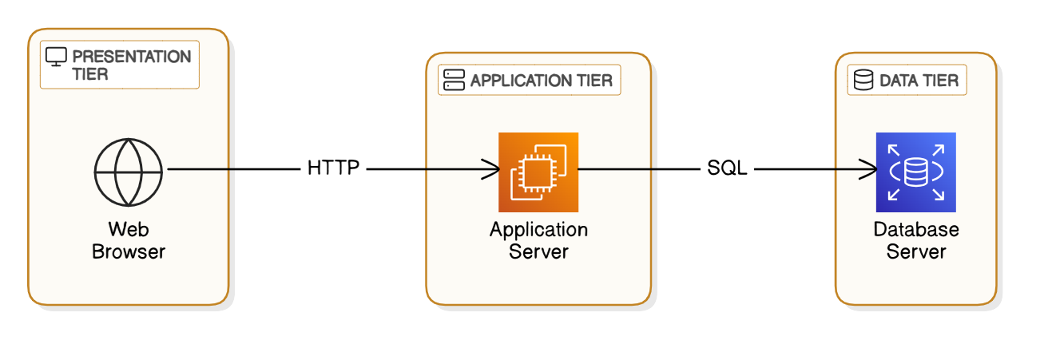

* **THEORY EXERCISE: What is the significance of modularity in software architecture?**

Importance of Modularity in Software Architecture:

Modularity is a way of taking a software system and breaking it up into independent modules that work together. This is important because

**1. Easier Maintenance  
Why it's important:** You can change or repair part of a system without breaking all of it.  
**Example:** Fixing bugs in one module don’t require changing other parts.

**2. Reusability  
Why it's important**: You can use the same module in different systems or projects.  
**Example:** A login module can be reused in many different apps.

**3. Better Collaboration**  
**Why it's important**: Teams can work on different parts of the system at the same time without interfering with each other.  
**Example**: One team works with the payment system, while another works with the interface.

**4. Scalability**  
**Why it's important**: With good modular design, adding new features is simple.  
**Example**: Add a reporting module without breaking other features.

**5. Improved Testing**  
**Why it's important**: You can test each part of the system separately, which makes it easier to find faults.  
**Example**: Test the payment system independently first before combining it into the main application.

**6. Flexibility  
Why it's important:** You can change and upgrade parts of a system without affecting the others.  
**Example:** You can replace one database with another with almost no disturbance to the rest of the system.

**7.Better Organization**  
**Why it's important**: Organized modules make the code more understandable.  
**Example**: Individual modules such as login, payments, and user management are easier to route.

**8. Reduced Complexity**  
**Why it's important**: Smaller systems are easier to manage than an entire system.  
**Example**: One area can be focused on for improvement such as the login system rather than enhancing the whole system simultaneously.

**Layers in Software Architecture**

* **LAB EXERCISE: Create a case study on the functionality of the presentation, business logic, and data access layers of a given software system**.

**Case Study: Online Food Ordering System**

1. **Presentation Layer**:
   * Displays menus and order details (e.g., user selects "Pizza").
   * Technologies: HTML, JavaScript, React.
2. **Business Logic Layer**:
   * Validates stock, calculates price, and processes payments.
   * Technologies: Java, Python, Node.js.
3. **Data Access Layer**:
   * Retrieves menu data and saves orders to the database.
   * Technologies: MySQL, MongoDB.

**Flow Example**

1. **User Action**: Adds "Pizza" to the cart.
2. **Flow**:
   * Presentation: Sends the item ID.
   * Business Logic: Validates availability.
   * Data Access: Fetches stock and updates inventory.
3. **Result**: Cart updates with the selected item.

* **THEORY EXERCISE: Why are layers important in software architecture?**

An application design is said to insulate an application for maintainability, scalability, and flexibility; these layers have many paramount characteristics arched in them:

**1.Separation of Concerns:**

Layers aid in separating views of the system; these views include the user interface, business logic, data access, and infrastructure. This imagined separation serves to make changes in one layer decoupled from changes in other layers; hence, one could say that maintenance and upgrades are simplified to a higher degree.

**2.Modularity:**

Layering lends itself to delivering a modular conformation through which different concerns can be dealt with during individual phases in each layer, testing, developing, and deploying different functional units with ease.

**3.Scalability:**

The layered architecture is very easy to scale. For example, if one has to scale up the business logic layer, one would not have to touch either the presentation or the data access layer, for the logic is encapsulated only in

the business logic layer.

**4.Flexibility and Extensibility:**

A good layer design allows the addition of new features and changing current functionality quite easily. For instance, the modification of a user interface becomes very easy without touching the business logic or the data storage mechanisms.

**5.Reusability:**

Different routes exist through which a piece of logic within a layer (say, business logic, for instance) can be reused within separate parts of an application or across applications without any duplication.

**6.Maintainability:**

Maintainability: Layered architecture makes it quite easy for debugging and maintenance of the application. The identification of what went wrong, once something went wrong, wouldn't be that much of a problem, since one can isolate one problem in one layer. This reduces debugging's complexity.

**Software Environments**

* **LAB EXERCISE: Explore different types of software environments (development, testing, production). Set up a basic environment in a virtual machine.**

**Objective**

The goal of this lab exercise is to explore different types of software environments—development, testing, and production—and understand their purposes. You will also learn to set up a basic environment in a virtual machine (VM).

**Understanding Software Environments**

1. **Development Environment**:
   * **Purpose**: Used by developers to write, debug, and test code.
   * **Features**: Frequent changes, test data, and debugging tools.
   * **Example**: A local setup with an IDE like IntelliJ IDEA or VS Code, Git for version control, and a local database.
2. **Testing Environment**:
   * **Purpose**: Used to verify the functionality of software before deployment.
   * **Features**: Mimics the production environment but uses test data.
   * **Example**: A staging server where QA teams perform manual or automated tests.
3. **Production Environment**:
   * **Purpose**: Used to run the final version of the software for end-users.
   * **Features**: Highly stable, optimized for performance, and contains real user data.
   * **Example**: A live website or mobile app accessed by users.

**Setting Up a Basic Environment in a Virtual Machine**

**Steps to Complete the Lab:**

1. **Choose a Virtual Machine Tool**:
   * Install software like VirtualBox or VMware Workstation.
2. **Download an Operating System**:
   * Select a Linux distribution (e.g., Ubuntu) as the OS image for the VM.
3. **Create a Virtual Machine**:
   * Configure the VM with sufficient resources (e.g., 2GB RAM, 20GB disk space).
4. **Install the OS**:
   * Use the downloaded OS image to install the operating system on the VM.
5. **Set Up the Development Environment**:
   * Update the system using the command:

sudo apt update && sudo apt upgrade

* + Install essential tools like a text editor, programming language, and web server:

sudo apt install vim git python3 openjdk-17-jdk apache2

* + Install essential tools like a text editor, programming language, and web server:

sudo apt install vim git python3 openjdk-17-jdk apache2

* + Start the web server:

sudo systemctl start apache2

* + Open a browser in the VM and visit http://localhost to confirm the server is running.
* **THEORY EXERCISE: Explain the importance of a development environment in software production.**

A development environment is important for software production because it provides the developers with the tools and configuration they need to speedily build, test, and debug the application. This environment improves efficiency in the processes and lives up to the vision of developing the software exactly in nature across several teams by keeping errors completely out of the picture in most instances.

**Key Benefits of a Development Environment**

1. **Productivity**Provides project managers and developers apprehensible tools such as course editors, debuggers, and compilers required for faster development.
2. **Consistency**Preconfigures the machine to behave uniformly no matter where the code runs across various systems.
3. **Testing**Provides a controlled environment in which to conduct tests for early detection and remediation of defects during the course of development.
4. **Collaboration**  
   Facilitates teamwork by allowing developers to work together seamlessly within a shared configuration.
5. **Version Control**

Tracks and manages code changes, preventing data loss and ensuring smooth updates throughout the development cycle.

A well-configured development environment promises to produce smoother, error-free, and quicker software. A well-configured development environment ensures smooth, error-free, and faster software production.

**Source Code**

* **LAB EXERCISE: Write and upload your first source code file to Github.**

**Step 1: Write Your First Source Code File**

1. Open a code editor (e.g., VS Code, Code::Blocks, Notepad++).
2. Write a simple C program. Here's an example:

// my_first_code.c

*#include <stdio.h>*

int main() {

    printf("Hello, GitHub!\n");

*return* 0;

}

Save the file as my_first_code.c.

**Step 2: Create a GitHub Repository**

1. Go to [GitHub](https://github.com/) and log in.
2. Click on the **+** icon in the top-right corner and select **New repository**.
3. Fill in the repository details:
   * **Repository name**: my-first-c-repo
   * **Description**: "This repository contains my first C source code file."
   * Choose visibility: Public or Private.
   * (Optional) Check **Add a README file**.
4. Click **Create repository**.

**Step 3: Upload Your C Source Code to GitHub**

1. **Using the GitHub Website:**
   * Open your GitHub repository.
   * Click **Add file > Upload files**.
   * Drag and drop my_first_code.c or click **choose your files** to upload it.
   * Add a commit message (e.g., "Added my first C source code file").
   * Click **Commit changes**.

**Step 4: Verify**

1. Go to your GitHub repository and ensure the file my_first_code.c is visible.
2. Open the file to check its content.

* **THEORY EXERCISE: What is the difference between source code and machine code?**

The main difference between **source code** and **machine code** lies in their form and purpose:

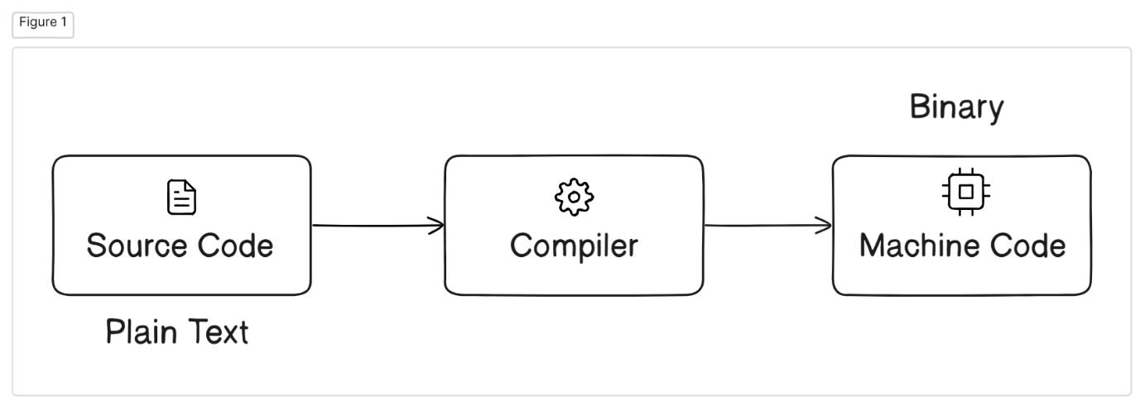

**Source Code**

* **Definition**: Human-readable instructions written in a programming language (e.g., Java, Python, C++,C) that developers write to create software.
* **Purpose:** Designed for humans to understand, write, and edit.
* **Examples:**

#include <stdio.h>

int main() {

    printf("Hello, World!\n");

*return* 0;

}

* **Execution:** Cannot be directly executed by a computer; needs to be translated (compiled or interpreted) into machine code.

**Machine Code**

* **Definition**: Binary code (0s and 1s) that the computer's CPU can directly execute.
* **Purpose**: Designed for the computer to understand and execute instructions.
* **Examples**: Binary or hexadecimal representation such as:  
  11001001 10111001
* **Execution**: Directly executed by the computer without further translation.

**Github and Introductions**

* **LAB EXERCISE: Create a Github repository and document how to commit and push code changes**

**Create a Repository**:

* Log in to GitHub, click the **+** icon, and select **"New repository"**.
* Name your repository, choose visibility (Public/Private), and click **"Create repository"**.

**Clone the Repository**:

git clone <repository_url>

cd <repository_name>

**Make and Commit Changes**:

* Edit or add files in the repository folder.

git add .

git commit -m "Your commit message"

**Push Changes**:

git push origin main

* **THEORY EXERCISE: Why is version control important in software development?**

Version control is important in software development because it helps:

1. **Collaboration**: Multiple people can work on the same project without conflicts.
2. **History**: Tracks changes and who made them, making it easy to debug.
3. **Backup**: Safely stores code and allows rollback if needed.
4. **Quality**: Enables code reviews and testing.
5. **Parallel Work**: Allows working on features or fixes separately.

Tools like Git make teamwork easier and projects more reliable.

**Student Account in Github**

* **LAB EXERCISE: Create a student account on Github and collaborate on a small project with a classmate.**

**Create a Student Account on GitHub**:

* Visit [GitHub](https://github.com/).
* Click on "Sign up" and fill in the required details.
* If you're a student, apply for the GitHub Student Developer Pack for extra benefits.

**Collaborate on a Small Project:**

* Create a new repository or fork an existing project on GitHub.
* Invite your classmate as a collaborator by going to the "Settings" tab of your repository and adding their GitHub username.
* Both you and your classmate can now make changes, commit, and push code to the repository.
* **THEORY EXERCISE: What are the benefits of using Github for students?**

GitHub offers several benefits for students, including:

1. **Free Access**: GitHub Student Pack provides free access to premium tools and services for learning and projects.
2. **Portfolio Building**: Students can showcase their projects and skills to potential employers.
3. **Collaboration**: Enables teamwork on projects, with tools for version control and code sharing.
4. **Learning Resources**: Access to open-source projects and communities for learning from real-world examples.
5. **Networking**: Connect with developers, contribute to projects, and build a professional network.
6. **Project Management**: Tools like issues, wikis, and project boards help manage tasks effectively.

**Types of Software**

* **LAB EXERCISE: Create a list of software you use regularly and classify them into the following categories: system, application, and utility software.**

**System Software:**

* Operating System (e.g., Windows, macOS, Linux)
* Device Drivers (e.g., Graphics Driver, Audio Driver)

**Application Software:**

* Microsoft Word (Word Processor)
* Google Chrome (Web Browser)
* Adobe Photoshop (Image Editing)
* Microsoft Excel (Spreadsheet)

**Utility Software:**

* Antivirus (e.g., Norton, McAfee)
* Disk Cleanup
* Backup Software (e.g., Acronis True Image)
* **THEORY EXERCISE: What are the differences between open-source and proprietary software?**

|  |  |  |
| --- | --- | --- |
| **Aspect** | **Open-Source** | **Proprietary** |
| **Source Code Access** | Publicly available, anyone can modify it | |  | | --- | | Source code is private, cannot be modified |  |  | | --- | |  | |
| |  | | --- | | **Cost** |  |  | | --- | |  | | |  | | --- | | Generally free or low-cost |  |  | | --- | |  | | |  | | --- | | Paid, requires a license or subscription |  |  | | --- | |  | |
| **Customization** | |  | | --- | | Fully customizable by anyone |  |  | | --- | |  | | Limited customization, cannot modify code |
| **Development** | |  | | --- | | Community-driven, open to contributions |  |  | | --- | |  | | Developed by a single company or organization |
| **Support** | Community support, forums, documentation | Official support from the company |
| **Security** | Community identifies and fixes vulnerabilities | Managed by the company, closed to outsiders |
| **Licensing** | Released under open licenses (e.g., GPL) | Licensed with restrictions on use and distribution |

**GIT and GITHUB Training**

* **LAB EXERCISE: Follow a GIT tutorial to practice cloning, branching, and merging repositories.**

**Clone the repository:**

git clone <repository-url>

**Create a new branch:**

git checkout -b <branch-name>

**Make changes, then commit:**

git add .

git commit -m "your message"

**Push the new branch:**

git push origin <branch-name>

**Switch to the main branch:**

git checkout main

**Merge the feature branch into main:**

git merge <branch-name>

**Push the merged changes to remote:**

git push origin main

**Optional: Delete the feature branch:**

git branch -d <branch-name>

git push origin --delete <branch-name>

* **THEORY EXERCISE: How does GIT improve collaboration in a software development team?**

Git improves collaboration in a software development team in several ways:

**1. Branching and Merging**

* Developers can work on separate branches for features or fixes without affecting the main project. Once the work is done, it can be merged back into the main branch, ensuring smooth integration.

**2. Version Control**

* Git tracks all changes made to the code, so team members can see who made what changes and when. This makes it easier to resolve conflicts and avoid duplication of work.

**3. Distributed System**

* Every team member has a local copy of the repository, so they can work independently and offline. Changes are only synchronized when ready, reducing dependency on a central server.

**4. Pull Requests**

* GitHub (or GitLab/Bitbucket) supports pull requests, where team members can review code changes before merging them into the main project. This ensures code quality and fosters collaboration.

**5. Conflict Resolution**

* Git helps identify and resolve merge conflicts when multiple developers change the same part of the code. It highlights conflicting areas and allows team members to fix them manually.

**6. History and Tracking**

* Git keeps a detailed history of changes, allowing team members to understand why a certain change was made. This is useful for troubleshooting or understanding project evolution.

**7. Collaboration on Open-Source Projects**

* Git makes it easy for developers worldwide to collaborate on open-source projects, share contributions, and integrate ideas from multiple contributors.

In short, Git streamlines teamwork, reduces conflicts, and helps maintain a smooth workflow in software development teams.

**Application Software**

* **LAB EXERCISE: Write a report on the various types of application software and how they improve productivity.**

**Report: Types of Application Software and How They Improve Productivity**

**Introduction**

Application software helps users perform tasks more efficiently. These tools are essential in various fields like business, education, and personal use, improving productivity in many ways. Below are different types of application software and how they enhance productivity.

**1. Word Processing Software**

**Examples:** Microsoft Word, Google Docs  
Helps in creating and editing documents. Features like spell check and templates save time and improve document quality.

**2. Spreadsheet Software**

**Examples:** Microsoft Excel, Google Sheets  
Used for organizing, analyzing, and calculating data. It speeds up tasks like budgeting and data analysis.

**3. Presentation Software**

**Examples:** Microsoft PowerPoint, Google Slides  
Creates visually engaging slideshows. It helps present ideas effectively and saves time with pre-built templates.

**4. Database Management Software**

**Examples:** Microsoft Access, MySQL  
Organizes and stores large amounts of data, making it easy to retrieve and analyze information.

**5. Email & Communication Software**

**Examples:** Gmail, Slack, Zoom  
Facilitates fast communication and collaboration through messaging, emails, and video calls, improving workflow.

**6. Graphic Design Software**

**Examples:** Adobe Photoshop, Canva  
Helps design visuals like logos and ads. It speeds up the design process and improves creativity.

**7. Project Management Software**

**Examples:** Trello, Asana  
Organizes tasks, tracks progress, and improves team coordination, ensuring projects stay on schedule.

**8. Accounting Software**

**Examples:** QuickBooks, Xero  
Simplifies financial tasks like invoicing and budgeting, reducing errors and saving time.

**9. Internet Browsers & Search Engines**

**Examples:** Google Chrome, Safari  
Helps users access information online quickly and easily, improving research and decision-making.

**10. Cloud Storage & File Management**

**Examples:** Google Drive, Dropbox  
Allows remote file storage and sharing, enabling access from anywhere and improving collaboration.

**Conclusion**

Application software boosts productivity by automating tasks, organizing information, and improving communication. These tools save time and help users perform tasks more efficiently across various fields.

* **THEORY EXERCISE: What is the role of application software in businesses?**

Application software helps businesses perform tasks more easily and efficiently. Here's how:

1. **Automation of Tasks**

* It automates routine tasks like payroll, inventory, and data entry, saving time and reducing errors.

1. **Increased Efficiency**

* It helps businesses streamline processes, like using accounting software to manage finances or CRM software to handle customer relations.

1. **Data Management**

* Businesses use software to store, organize, and analyze data, helping them make better decisions.

1. **Communication and Collaboration**

* Software like email and messaging apps improve communication within teams and with customers.

1. **Customer Service**

* It helps businesses provide better customer service by tracking customer interactions and feedback.

1. **Cost Savings**

* Automation and efficient processes help businesses save money by reducing manual labor and mistakes.

1. **Security and Compliance**

* Software keeps business data safe and helps meet legal requirements.

1. **Scalability**

* As a business grows, software can be upgraded or expanded to handle more work.

**In Simple Terms:**

Application software makes business tasks faster, more accurate, and easier to manage. It helps businesses run smoothly and grow efficiently.

**Software Development Process**

* **LAB EXERCISE: Create a flowchart representing the Software Development Life Cycle (SDLC).**

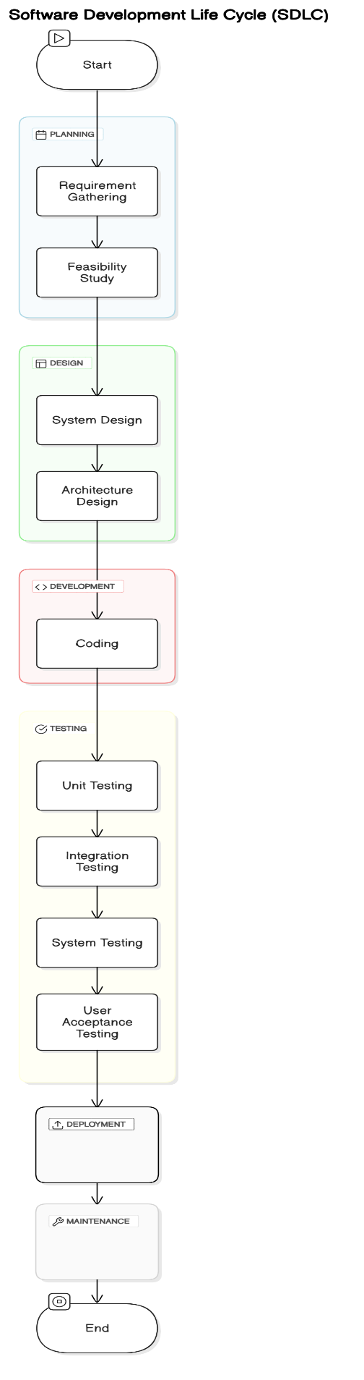

* **THEORY EXERCISE: What is the role of application software in businesses?**

The software development process typically follows several key stages to create and maintain a software product. Here are the main stages:

1. **Planning**

* This is the initial stage where the project's goals, scope, timeline, and resources are defined. It includes gathering requirements from stakeholders and creating a project plan.

1. **Analysis**

* In this stage, the requirements are analyzed in detail to understand the problems the software will solve. This helps in defining functional and non-functional requirements and creating a clear blueprint for development.

1. **Design**

* Based on the analysis, the system’s architecture, user interfaces, and components are designed. The design phase also includes selecting technologies and tools for development.

1. **Implementation (Coding)**

* This is the actual development phase where programmers write the code according to the design specifications. It’s where the software starts to take shape.

1. **Testing**

* After the software is developed, it undergoes testing to identify and fix bugs, errors, or any issues. Testing can be done at different levels like unit testing, integration testing, and system testing.

1. **Deployment**

* Once the software is tested and ready, it is deployed to the users or customers. This stage may involve installation, configuration, and training for users.

1. **Maintenance**

* After deployment, the software enters the maintenance phase, where it is updated regularly, bugs are fixed, and new features or enhancements are added.

**In Simple Terms:**

1. **Planning:** Decide what to build.
2. **Analysis:** Understand what is needed.
3. **Design:** Plan how it will work.
4. **Implementation:** Write the code.
5. **Testing:** Check if it works.
6. **Deployment:** Make it available to users.
7. **Maintenance:** Keep it updated and fixed.

These stages help ensure that the software meets user needs, works as intended, and is continuously improved.

**Software Requirement**

* **LAB EXERCISE: Write a requirement specification for a simple library management system.**

**Library Management System Requirements**

**1. Overview**

The Library Management System helps manage books, members, and borrowing/returning activities in a simple and efficient way.

**2. Features**

**User Management:**

* Members can register, log in, and update their profiles.
* Admins have full control over the system.

**Book Management:**

* Add, edit, or remove books.
* Search for books by title, author, or genre.
* Check book availability.

**Borrow and Return:**

* Members can borrow and return books.
* The system tracks due dates and overdue fines.

**Reports and Notifications:**

* Admins can see reports of borrowed books and member activity.
* Members get reminders for due dates and fines.

**3. Technical Details**

* **Platform:** Web-based system accessible via any browser.
* **Database:** Stores book and user information securely.
* **Scalability:** Can handle more members and books as needed.

**4. Assumptions**

* Members can borrow up to 5 books at a time.
* Fines are $1 per day for overdue books.
* **THEORY EXERCISE: Why is the requirement analysis phase critical in software development?**

The **requirement analysis phase** is very important in software development because it sets the foundation for the entire project. Here’s why it matters:

**1. Understanding What People Want**

* This phase helps developers understand exactly what the client or users need from the software.
* It ensures the project delivers what’s expected.

**2. Avoiding Confusion**

* Clear requirements reduce misunderstandings between the team and stakeholders.
* Everyone knows what to do and what the final product should look like.

**3. Defining the Project’s Scope**

* It sets clear boundaries for the project, so the team knows what to include and what to leave out.
* This prevents the project from getting bigger or more complicated than planned.

**4. Checking Feasibility**

* It helps determine if the requested features are possible to build within the available time, budget, and technology.

**5. Planning Time and Cost**

* With clear requirements, it’s easier to estimate how long the project will take and how much it will cost.
* This helps avoid surprises later.

**6. Building High-Quality Software**

* When requirements are clear, the team can create better designs and solutions, leading to a better product.

**7. Making Testing Easier**

* Requirements provide a guide for testing, making sure the software does what it’s supposed to do.

**8. Saving Time and Money**

* Solving any issues or unclear points early prevents expensive changes or fixes later in the project.

**9. Keeping Everyone Happy**

* When the team involves stakeholders in this phase, they feel confident that the final product will meet their needs.

**In Simple Terms:**

The requirement analysis phase is like making a clear plan before building a house. It helps avoid mistakes, saves time, and ensures everyone is happy with the result. Skipping this step can lead to confusion, delays, and wasted resources, so it’s a must for a successful project.

**Software Analysis**

* **LAB EXERCISE: Perform a functional analysis for an online shopping system**

**1.User Management**

* **Register/Login:** User registration, authentication, and profile management.
* **User Roles:** Differentiation between customers, admins, and guest users.

**2. Product Management**

* **Product Catalog:** Display products with details like name, description, price, and image.
* **Search & Filter:** Enable users to search and filter products by categories, price range, etc.
* **Product Details:** Detailed view of individual products.

**3. Shopping Cart**

* **Add/Remove Items:** Add items to the cart or remove them.
* **Update Quantity:** Change the quantity of items in the cart.
* **View Cart:** Show cart summary, including item details, quantity, and total price.

**4. Order Management**

* **Checkout:** Collect shipping address, payment method, and order confirmation.
* **Order Tracking:** Allow users to track order status (e.g., pending, shipped, delivered).
* **Order History:** View past orders for registered users.

**5. Payment System**

* **Payment Integration:** Support for multiple payment methods (credit/debit cards, UPI, wallets).
* **Payment Security:** Implement secure payment gateways and encryption.

**6. Notification System**

* **Order Updates:** Email/SMS notifications for order placement, dispatch, and delivery.
* **Promotions:** Inform users about sales, discounts, and new arrivals.

**7. Administration Features**

* **Product Management:** Add, update, and delete products from the catalog.
* **Order Management:** Monitor and update the status of user orders.
* **User Management:** Manage user roles and permissions.

**8. Additional Features**

* **Reviews & Ratings:** Allow users to review and rate products.
* **Wishlist:** Enable users to save products for future purchase.
* **Recommendations:** Suggest products based on user preferences and history.

This high-level functional breakdown provides an overview of core features for an online shopping system.

* **THEORY EXERCISE: What is the role of software analysis in the development process?**

Software analysis is essential in the development process as it helps understand user needs, define requirements, and create a clear plan for building the software. It breaks down complex problems, ensures feasibility, and identifies potential risks early. By acting as a guide, it improves communication among stakeholders, supports testing, and reduces costly mistakes, ultimately ensuring the software meets expectations and is delivered efficiently.

**System Design**

* **LAB EXERCISE: Design a basic system architecture for a food delivery app**.

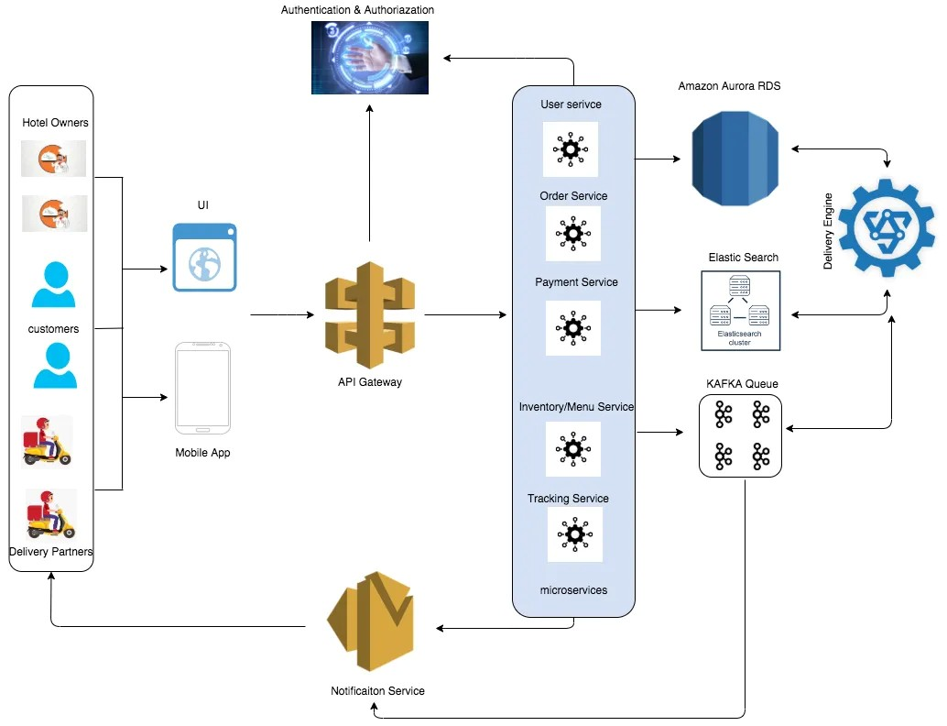

* **THEORY EXERCISE: What are the key elements of system design?**
* **Architecture Design** – Overall structure of the system.
* **UI Design** – User-friendly interface and experience.
* **Data Design** – Structuring and storing data.
* **Component Design** – Breaking the system into parts.
* **Integration Design** – Ensuring components work together.
* **Security Design** – Protecting the system and data.
* **Performance Design** – Meeting speed and efficiency needs.
* **Hardware/Software Specs** – Identifying required resources.
* **System Constraints** – Working within limitations.
* **Testing Design** – Ensuring quality and functionality.

**Software Testing**

* **LAB EXERCISE: Develop test cases for a simple calculator program.**

**Code:**

def test_calculator():

*# Test Addition*

*assert* (5 + 3) == 8

*assert* (-5 + (-3)) == -8

*assert* (5 + (-3)) == 2

*assert* (5 + 0) == 5

*# Test Subtraction*

*assert* (5 - 3) == 2

*assert* (3 - 5) == -2

*assert* (5 - 0) == 5

*assert* (-5 - 3) == -8

*# Test Multiplication*

*assert* (5 * 3) == 15

*assert* (-5 * (-3)) == 15

*assert* (5 * (-3)) == -15

*assert* (5 * 0) == 0

*# Test Division*

*assert* (6 / 3) == 2

*assert* (-6 / 3) == -2

*assert* (6 / -3) == -2

*try*:

*assert* (5 / 0)  *# Division by zero*

*except* ZeroDivisionError:

*pass*

*assert* (0 / 5) == 0

*# Edge Cases*

*assert* (1000000000 + 999999999) == 1999999999

*assert* (5.5 + 3.2) == 8.7

*assert* (7 / 3) == 2.3333333333333335

*# Invalid Input*

*try*:

*assert* (5 @ 3)  *# Invalid operation*

*except* TypeError:

*pass*

*assert* ("" == "")  *# Empty input check*

*# Multiple Operations*

*assert* (5 + 3 * 2) == 11

*assert* ((5 + 3) * 2) == 16

    print("All test cases passed!")

*# Run the test*

test_calculator()

**Output**:

All test cases passed!

* **THEORY EXERCISE: Why is software testing important?**

Software testing is important because it ensures quality, reliability, and performance of software by identifying bugs and issues early. It reduces costs, enhances user experience, ensures security, verifies compliance with standards, and prevents future problems. Testing guarantees that the software meets user requirements and operates efficiently, contributing to a successful and reliable product.

**Maintenance**

* **LAB EXERCISE: Document a real-world case where a software application required critical maintenance.**

**Case Study: Boeing 737 MAX Software Maintenance Issue**

**Background**

The Boeing 737 MAX aircraft required critical software maintenance following two tragic crashes in 2018 and 2019. The crashes were linked to issues in the **Maneuvering Characteristics Augmentation System (MCAS)**, a software system designed to prevent the aircraft from stalling.

**Problem**

1. **Flawed Logic in MCAS**:
   * The system relied on data from a single angle-of-attack (AOA) sensor. A faulty sensor caused the system to repeatedly push the aircraft’s nose down.
2. **Inadequate Alerts**:
   * Pilots were not adequately informed about the system or trained to handle MCAS-related malfunctions.
3. **System Override**:
   * MCAS repeatedly overrode pilot input, leading to catastrophic failures.

**Critical Maintenance**

1. **Software Update**:
   * Boeing developed a software patch to:
     + Use data from two AOA sensors instead of one.
     + Prevent repeated MCAS activation if the data is inconsistent.
   * Included an override mechanism allowing pilots to disable MCAS if needed.
2. **Pilot Training**:
   * Comprehensive training programs were introduced to familiarize pilots with MCAS behavior and failure recovery procedures.
3. **Regulatory Approval**:
   * The Federal Aviation Administration (FAA) and other global aviation bodies thoroughly tested and approved the updated software.

**Outcome**

* The updated software was successfully implemented across all Boeing 737 MAX aircraft.
* The aircraft resumed service in 2020 after regulatory clearance.
* This case highlighted the importance of robust software design, continuous monitoring, and effective training in mission-critical applications.

**Key Lessons**

1. **Redundancy**:
   * Systems relying on single points of failure pose significant risks.
2. **Transparency**:
   * Informing and training end-users on system behavior is crucial.
3. **Proactive Maintenance**:
   * Identifying and addressing potential issues during design and testing stages is vital to avoid critical failures.

This real-world example underscores the importance of timely and effective software maintenance in critical systems.

* **THEORY EXERCISE: What types of software maintenance are there?**

Software maintenance is categorized into four main types, each addressing different aspects of maintaining and improving software:

**Corrective Maintenance:**

* Focuses on fixing errors, bugs, and defects found after the software is released. It addresses problems that prevent the software from functioning as intended.

**Adaptive Maintenance:**

* Involves modifying software to ensure it remains compatible with changing environments, such as updates in hardware, operating systems, or third-party tools.

**Perfective Maintenance:**

* Enhances or improves the software's functionality, performance, or usability based on user feedback or new requirements, even if the system is working correctly.

**Preventive Maintenance:**

* Aims to detect and address potential issues before they become critical, improving the system's stability and extending its life. This includes code optimization and documentation updates.

**Development**

* **THEORY EXERCISE: What are the key differences between web and desktop applications?**

**Platform:**

* Web apps are platform-independent, run in browsers.
* Desktop apps are platform-specific, require installation.

**Accessibility:**

* Web apps need internet and can be accessed anywhere.
* Desktop apps work only on installed devices, often offline.

**Updates:**

* Web apps update on servers, instantly available.
* Desktop apps need manual updates.

**Performance:**

* Web apps rely on internet speed.
* Desktop apps use local resources, generally faster.

**Data Storage:**

* Web apps store data on servers/cloud.
* Desktop apps store data locally.

**Web Application**

* **THEORY EXERCISE: What are the advantages of using web applications over desktop applications?**
* Accessible anywhere with internet and a browser.
* Platform-independent; no installation needed.
* Automatic updates via the server.
* Cost-effective for deployment and maintenance.
* Easily scalable for more users or traffic.
* Enables real-time collaboration.
* Cloud storage ensures backups and easy recovery.
* Minimal reliance on device resources.
* Works across multiple devices seamlessly.
* Reduced data loss risk with secure server storage.

**Designing**

* **THEORY EXERCISE: What role does UI/UX design play in application development?**

1. **Enhances User Satisfaction**:

* A well-designed UI/UX ensures an intuitive and pleasant user experience, boosting satisfaction and engagement.

1. **Improves Usability**:

* Simplifies navigation and functionality, enabling users to achieve their goals efficiently.

1. **Drives User Retention**:

* A visually appealing and functional interface encourages users to keep using the application.

1. **Boosts Accessibility**:

* Incorporates design principles that cater to diverse user needs, including those with disabilities.

1. **Reduces Learning Curve**:

* Intuitive designs make it easier for new users to understand and use the application without extensive training.

1. **Supports Brand Identity**:

* Consistent UI/UX design reinforces the brand's image, making the application more recognizable and trustworthy.

1. **Increases Conversion Rates**:

* A user-friendly design guides users effectively toward desired actions, like purchases or sign-ups.

1. **Reduces Development Costs**:

* Addressing usability issues during design minimizes costly revisions later in development.

1. **Fosters Competitive Advantage**:

* Superior UI/UX differentiates an application from competitors, attracting more users.

**Mobile Application**

* **THEORY EXERCISE: What are the differences between native and hybrid mobile apps?**

|  |  |  |
| --- | --- | --- |
| **Aspect** | **Native Apps** | **Hybrid Apps** |
| **Development** | Platform-specific (e.g., Swift, Kotlin). | Cross-platform (HTML, CSS, JS). |
| **Performance** | High, optimized for the platform. | Slower, depends on WebView. |
| **Access to Features** | Full access to device APIs. | Limited, uses plugins for access. |
| **UX** | Seamless, platform-optimized. | May lack native feel. |
| **Cost** | Higher, separate codebases needed. | Lower, single codebase for all. |
| **Development Time** | Longer due to separate apps. | Faster with shared codebase. |
| **Examples** | WhatsApp, Instagram (native builds). | Uber, older Twitter (hybrid). |

**DFD(Data Flow Diagram)**

* 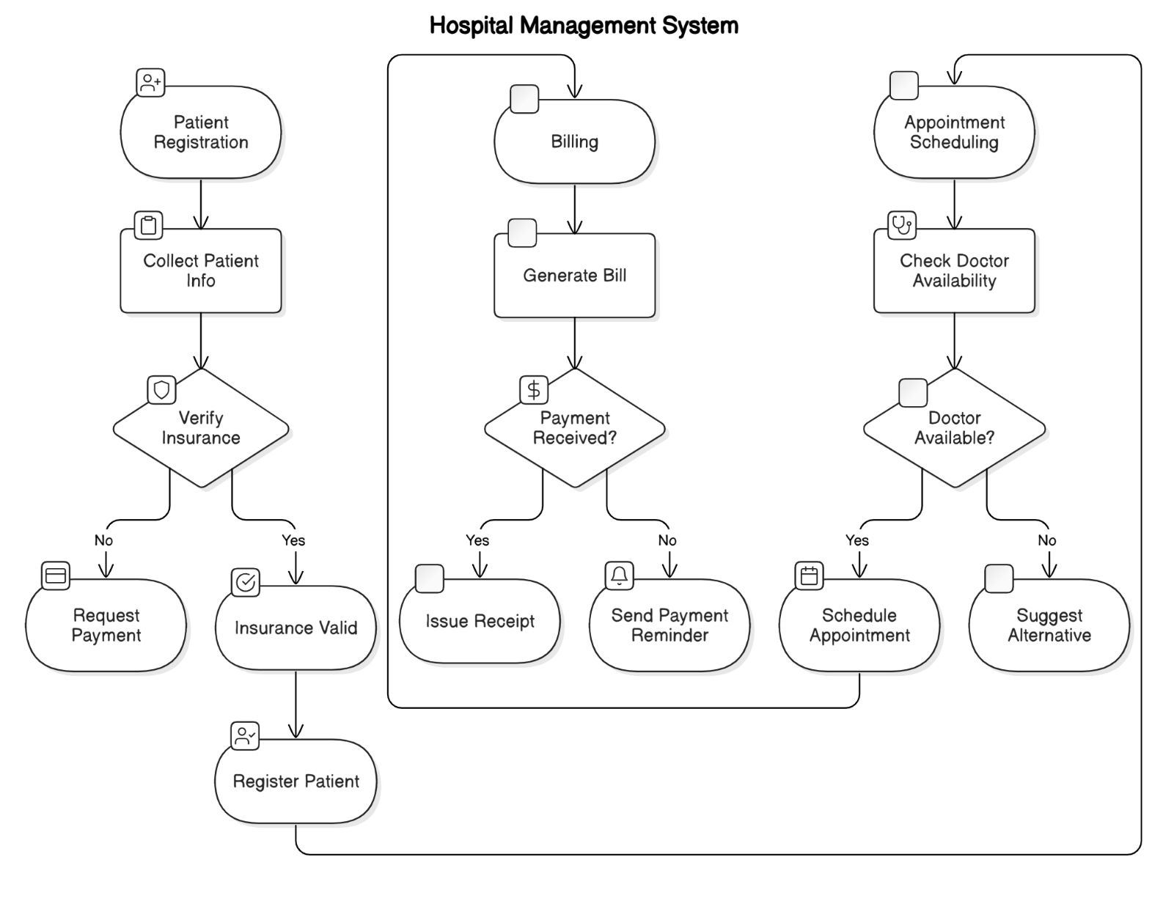**LAB EXERCISE: Create a DFD for a hospital management system.**
* **THEORY EXERCISE: What is the significance of DFDs in system analysis?**

A **Data Flow Diagram (DFD)** is important in system analysis because it:

1. **Visualizes Data Movement**: Shows how data flows between processes, data stores, and external entities.
2. **Simplifies Understanding**: Helps both technical and non-technical stakeholders understand the system.
3. **Identifies Issues**: Highlights inefficiencies, bottlenecks, or missing elements in the system.
4. **Supports Design**: Serves as a blueprint for system design and improvements.
5. **Documents the System**: Acts as a reference for future maintenance.
6. **Breaks Down Complexity**: Provides detailed views through levels (e.g., Level 0, Level 1).

It ensures clarity and structure in analyzing and designing systems.

**Desktop Application**

* **LAB EXERCISE: Build a simple desktop calculator application using a GUI library.**

**Code :**

*import* tkinter *as* tk

*from* tkinter *import* messagebox

*# Function to handle button clicks*

def button_click(*number*):

    current = entry.get()

    entry.delete(0, tk.END)

    entry.insert(0, current + str(number))

*# Function to clear the input field*

def clear():

    entry.delete(0, tk.END)

*# Function to evaluate the expression*

def calculate():

*try*:

        result = eval(entry.get())

        entry.delete(0, tk.END)

        entry.insert(0, str(result))

*except* Exception *as* e:

        messagebox.showerror("Error", "Invalid Expression")

*# Create the main window*

window = tk.Tk()

window.title("Calculator")

window.geometry("300x400")

window.resizable(False, False)

*# Entry widget for the display*

entry = tk.Entry(window, *width*=25, *font*=('Arial', 16), *justify*='right')

entry.grid(*row*=0, *column*=0, *columnspan*=4, *padx*=10, *pady*=10)

*# Button layout*

buttons = [

    ('7', 1, 0), ('8', 1, 1), ('9', 1, 2), ('/', 1, 3),

    ('4', 2, 0), ('5', 2, 1), ('6', 2, 2), ('*', 2, 3),

    ('1', 3, 0), ('2', 3, 1), ('3', 3, 2), ('-', 3, 3),

    ('C', 4, 0), ('0', 4, 1), ('=', 4, 2), ('+', 4, 3),

]

*# Create buttons dynamically*

*for* (text, row, col) *in* buttons:

*if* text == '=':

        button = tk.Button(window, *text*=text, *width*=5, *height*=2, *font*=('Arial', 14),

*command*=calculate)

*elif* text == 'C':

        button = tk.Button(window, *text*=text, *width*=5, *height*=2, *font*=('Arial', 14),

*command*=clear)

*else*:

        button = tk.Button(window, *text*=text, *width*=5, *height*=2, *font*=('Arial', 14),

*command*=lambda *t*=text: button_click(t))

    button.grid(*row*=row, *column*=col, *padx*=5, *pady*=5)

*# Run the application*

window.mainloop()

**Output:**

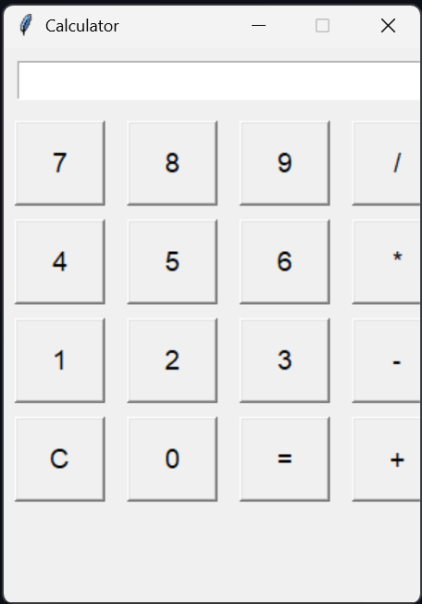

* **THEORY EXERCISE: What are the pros and cons of desktop applications compared to web applications?**

**Desktop Applications**

**Pros**:

* Faster performance.
* Works offline.
* Access to system resources.
* Enhanced security.

**Cons**:

* Platform-dependent.
* Requires installation.
* Manual updates.

**Web Applications**

**Pros:**

* Accessible anywhere.
* Cross-platform compatibility.
* No installation required.
* Automatic updates.

**Cons:**

* Needs internet connection.
* Slower performance.
* Limited access to hardware.
* Potential security risks.

**Flow Chart**

* **LAB EXERCISE: Draw a flowchart representing the logic of a basic online registration system.**

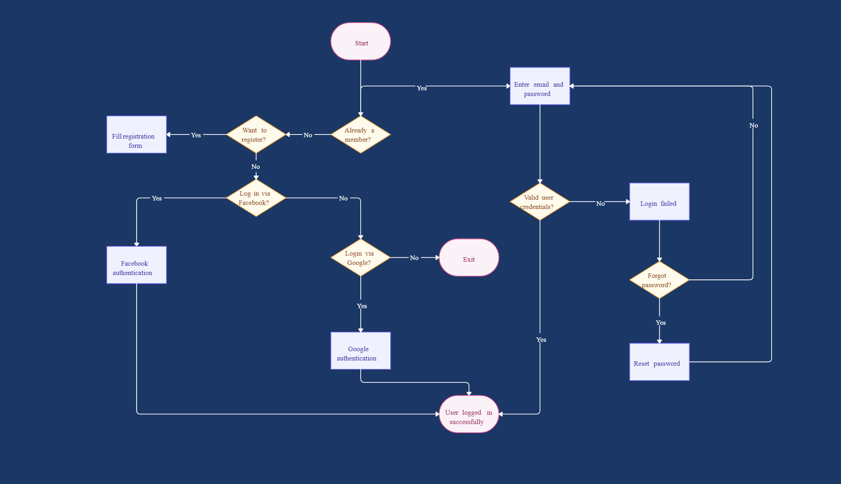

* **THEORY EXERCISE: How do flowcharts help in programming and system design?**

1. **Visual Representation**
   * Flowcharts provide a clear, graphical way to represent processes, making it easier to understand the system's flow.
2. **Simplify Complex Logic**
   * Break down complex algorithms or processes into manageable steps.
3. **Improve Communication**
   * Helps developers, designers, and stakeholders communicate ideas effectively without technical jargon.
4. **Identify Issues**
   * Makes it easier to spot logical errors, bottlenecks, or inefficiencies.
5. **Planning and Documentation**
   * Acts as a blueprint during development and as a reference for future maintenance.
6. **Better Debugging**
   * Simplifies the identification of problem areas in a system by following the process visually.
7. **Training and Onboarding**
   * Assists new team members in quickly understanding the system's structure and flow.

Flowcharts are invaluable tools for improving clarity, efficiency, and collaboration in programming and system design.